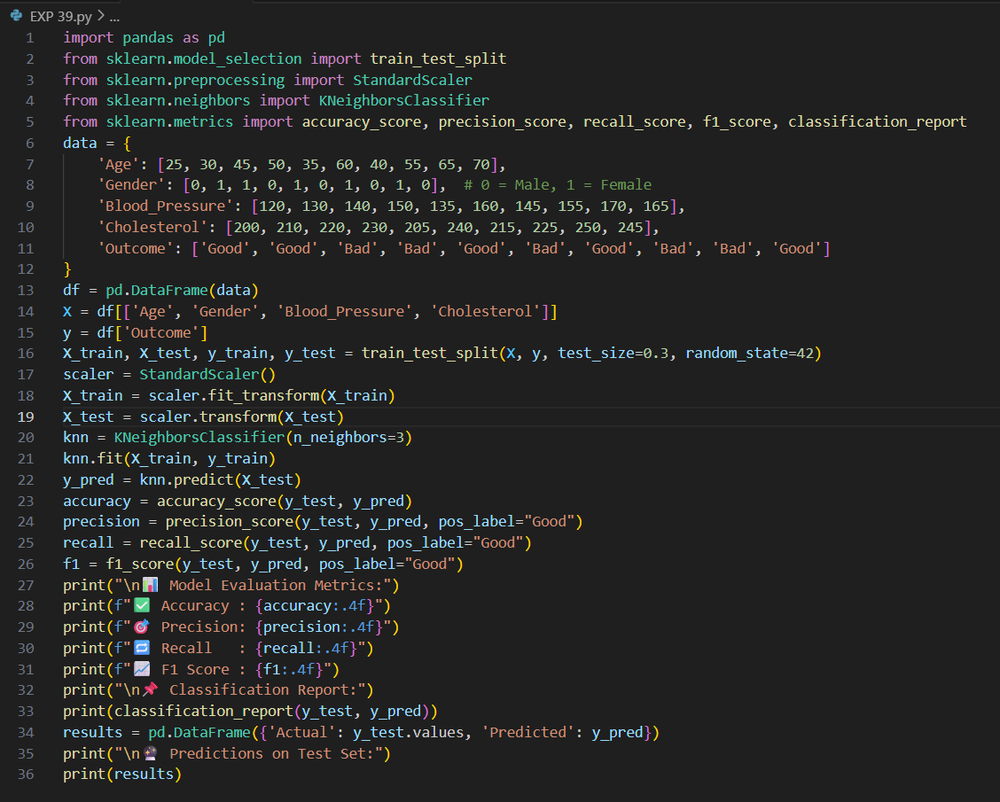

OUTPUT:

📊 Model Evaluation Metrics:

✅ Accuracy : 1.0000

🎯 Precision: 1.0000

🔁 Recall : 1.0000

📈 F1 Score : 1.0000

📌 Classification Report:

precision recall f1-score support

Bad 1.00 1.00 1.00 2

Good 1.00 1.00 1.00 1

accuracy 1.00 3

macro avg 1.00 1.00 1.00 3

weighted avg 1.00 1.00 1.00 3

🔮 Predictions on Test Set:

Actual Predicted

0 Bad Bad

1 Good Good

macro avg 1.00 1.00 1.00 3

weighted avg 1.00 1.00 1.00 3

🔮 Predictions on Test Set:

Actual Predicted

0 Bad Bad

1 Good Good

weighted avg 1.00 1.00 1.00 3

🔮 Predictions on Test Set:

Actual Predicted

0 Bad Bad

1 Good Good

🔮 Predictions on Test Set:

Actual Predicted

0 Bad Bad

1 Good Good

🔮 Predictions on Test Set:

Actual Predicted

0 Bad Bad

1 Good Good

0 Bad Bad

1 Good Good

2 Bad Bad